​

| **Variables** | **Type** | **Explanation** |
| --- | --- | --- |
|  |  |  |
| **StartDate** | **time** | **When started** |
| **EndDate** | **time** | **When ended** |
| **IPAddress** | **geo** | **IP address** |
| **Duration (in seconds)** | **time (secs)** | **how long it took to complete entire Qualtrics** |
| **RecordedDate** | **time** | **Date recorded** |
| **ResponseId** | **cat** | **Qualtrics Identifier** |
| **LocationLatitude** | **geo** | **Lat where they complete it** |
| **LocationLongitude** | **geo** | **Long wher ethe completed it** |
| **UserLanguage** | **cat** | **Language chosen** |
| **id** | **string** | **Prolific id** |
| **t1g1Comp** | **cat** | **Comp check stag hunt** |
| **stag** | **cat** | **Stag hunt strategy** |
| **timer1_Page Submit** | **time (secs)** | **timer for stag hunt choice** |
| **timer1_Click Count** | **num** | **click count stag page** |
| **t1Dnorm1** | **cat** | **subject expected modal action stag hunt** |
| **t1Snorm1** | **cat** | **subject beliefs, socialy normative action stag hunt** |
| **t1g2Comp2** | **time (secs)** | **Comp check pgg** |
| **transferredpgg** | **num** | **pgg strategy [0,100]** |
| **timer2 _Page Submit** | **time (secs)** | **timer for pgg choice** |
| **timer2 _Click Count** | **num** | **click count pgg page** |
| **t1DNorm2_3** |  | **subject expected modal action pgg** |
| **t1SNorm2_1** |  | **subject beliefs, socialy normative action pgg** |
| **t1g3Comp** |  | **Comp check dictator** |
| **sentdictator** | **num** | **dictator strategy [0,100]** |
| **timer3 _Page Submit** | **time (secs)** | **timer for dictator page** |
| **timer3 _Click Count** | **num** | **click count dictator page** |
| **t1DNorm3_1** | **nun** | **subject expected modal action dictator** |
| **t1SNorm3_1** | **num** | **subject beliefs, socialy normative action dictator** |
| **trust comp 1** | **cat** | **comp check trust game** |
| **trust comp 2** | **cat** | **comp check trut game 2** |
| **action4rolea** | **cat** | **trust game strategy role a** |
| **action4roleb** | **cat** | **trust game strategy role b** |
| **timer4 _Page Submit** | **time (secs)** | **timer for trust game page** |
| **timer4 _Click Count** | **num** | **click count trust game page** |
| **dnormtrustrolea** | **cat** | **subject expected modal action tg role a** |
| **dnormtrustroleb** | **cat** | **subject expected modal action tg role a** |
| **trustsn** | **cat** | **subject beliefs, socialy normative action tg** |
| **Lotteries** | **cat** | **Eckel & Grossman Risk tolerance measure** |
| **heart** | **cat** | **comp check** |
| **falkpatience _1** | **num** | **Falk et al. patience measure [0,100]. Like discounting** |
| **waterpipebechtel** | **cat** | **Bechtel policy patience measure [0,1]. Like discounting** |
| **politics_1** | **num** | **Political orientation [0,100]** |
| **about** | **string** | **what subject thinks the study is about** |
| **kinship** | **string** | **how the subject defines 'kinship'** |
| **combat** | **cat** | **whether the subject served in a combat zone at any time in service** |
| **UCLA8scale _1-8** | **cat** | **loneliness measures** |
| **bigfiveshort _1-10** | **cat** | **personality measures** |
| **locus of control _1-20** | **cat** | **control measures** |
| **idx** | **string** | **same as Prolific id** |
| **Reviewed at** | **time** | **When Jobu reviewed the entry on Prolific** |
| **Completion code** | **string** | **Completion code assigned. It's messed up so ignore** |
| **Total approvals** | **num** | **Subject prolific experience** |
| **Age** | **num** | **Subject age** |
| **Sex** | **cat** | **Subject sex identitication** |
| **Ethnicity simplified** | **cat** | **Simple ethnicity category** |
| **Country of birth** | **cat** | **Country of birth** |
| **Country of residence** | **cat** | **Country of residence** |
| **Nationality** | **cat** | **Nationality** |
| **Language** | **cat** | **Language** |
| **Student status** | **cat** | **Student status** |
| **Employment status** | **cat** | **Employment status** |
| **service** | **cat** | **Where they served** |
| **vet** | **cat** | **binary, veteran of military service** |
| **session** | **cat** | **Prolific session id** |
| **Submission id** | **string** | **Prolific entry id** |

### **Veterans groups**

First group is non-veterans are vet==No.

Second group is non-combat veterans, where combat==”No’ and vets==yes.

Third group is combat veterans where combat==yes.

### **Coding Psychometrics:**

**Risk Aversion (Eckel and Grossman method)**

Create a new variable called “risktolerance.” It will take integer values between one (risk-averse) and five (risk-loving).

Code the variable in the following fashion:

* for Lotteries starting with ='Gamble 1' risktolerance==1
* Lotteries starting with ='Gamble 2' risktolerance==2
* Lotteries starting with ='Gamble 3' risktolerance==3
* Lotteries starting with ='Gamble 4' risktolerance==4
* Lotteries starting with ='Gamble 5' risktolerance==5

**UCLA-8 Loneliness scale:**

* UCLA8scale _1, UCLA8scale _2, UCLA8scale _3, UCLA8scale _4, UCLA8scale _5, UCLA8scale _6, UCLA8scale _7, UCLA8scale _8. They capture feelings of loneliness. For UCLA8scale _1, UCLA8scale _2, UCLA8scale _4, UCLA8scale _5, UCLA8scale _7, UCLA8scale _8, code: often=4 sometimes=3 rarely=2 never=1.
* For UCLA8scale _3 and UCLA8scale _6, code: often=1 sometimes=2 rarely=3 never=4.
* Create a new variable called lscore, which is the sum of the new numerical values of UCLA8scale _1, UCLA8scale _2, UCLA8scale _3, UCLA8scale _4, UCLA8scale _5, UCLA8scale _6, UCLA8scale _7, UCLA8scale _8 for each row.
* Lscore should take an integer value in [8,32]. We typically standardize this measure before running regressions.

**Big Five (Short)**

* **Coming soon**

**Locus of Control**

* Refer to <https://faculty.darden.virginia.edu/clawsonj/General/SELF_ASSESSMENT_TOOLS/OB-786_Locus_of_Control.pdf>

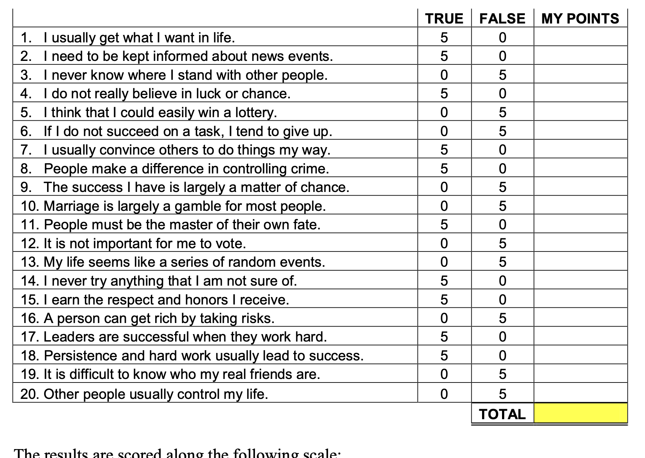

* Create a new variable ‘locus’ =sum of values across rows. Locus Lscore should take an integer value in [0,100].
* Low scores(0-35) indicate internal locus of control, and high scores (65-100) indicate external.